CORRESPONDING AUTHOR:Dr.Ramniwas dhukiya ,S/o Ladu Ram dhukiya V.P.O.-Binasar,,Tehsil and District-Churu, Rajasthan 331031.Email: dr.ramniwas1985@gmail.com Mobil no. +919460651460

Kikuchi's disease: a case report from west india
dhukiya Ramniwas*¹, Kajla ramakishan²,Dhukiya Saroj³, chouhan S.P⁴, Khedar Rakesh kumar⁵,Sinwar Prabhu dyal⁶
1. Senior Resident, Department of General Surgery, Sardar Patel Medical College Bikaner.
2. Associate Professor, Department of General Surgery, Sardar Patel Medical College Bikaner 3.Senior Demonstrator, Department of Physiology, Sardar Patel Medical College Bikaner
4. Professor, Department of General Surgery, Sardar Patel Medical College Bikaner
5. Resident, Department of General Surgery, Sardar Patel Medical College Bikaner.
6. Senior Resident, Department of General Surgery, Sardar Patel Medical College Bikaner.

ABSTRACT
Introduction
Kikuchi-Fujimoto disease (KFD), or histiocytic necrotizing lymphadenitis, is a rare benign, self-limiting cervical lymphadenitis of unknown etiology. It closely mimic infective and immunological disorders. CASE REPORT- we report a 20-year-old male of west presented with multiple neck swellings and fever of 15 days duration. Clinical Examination revealed unilateral large, mobile and tender-cervical lymphadenopathy. Lymph nodes were not palpable in other parts of the body. Examination of other systems was normal. Routine hematological parameters were within normal limits. ESR was 90mm/1st hr. Fine needle aspiration cytology (FNAC) of the right supraclavicular cervical node showed features suggestive of reactive lymphadenitis. After that, lymph node biopsy was done and the histological features suggested the diagnosis of Kikuchi-Fujimoto disease. The Patient was treated symptomatically with nonsteroidal anti-inflammatory drugs and the lymph nodes regressed in four weeks. Conclusion- Although the incidence of Kikuchi-Fujimoto disease is rare, Kikuchi Fujimoto disease is considered a disorder with a self-limited course and af avorable outcome.
Keyword:Kikuchi ,Lymphadenopathy,Biopsy,.

INTRODUCTION

Kikuchi-Fujimoto disease (KFD; so-called histiocytic necrotizing lymphadenitis is an enigmatic, benign, and selflimited syndrome characterized by regional lymphadenopathy with tenderness, usually accompanied by mild fever and night sweats. Initially described in Japan, KFD was first reported almost simultaneously by Kikuchi and by Fujimoto and associates in 1972 as a lymphadenitis with focal proliferation of reticular cells accompanied by numerous histiocytes and extensive nuclear debris^{[1]}. The cause of Kikuchi-Fujimoto disease is unknown. Some kind of viral or post viral etiology has been proposed. There have also been reports of a possible link between KFD and systemic lupus erythematosus (SLE). Kikuchi- Fujimoto disease is an extremely rare disease. Its incidence has been reported worldwide with a higher among Japanese and other Asiatic individuals. KFD is more common in females compared to males with a male to female ratio of 1:4. People under 30 years of age are more affected by this disease than any other age group^{[2]} .

CASE REPORT

A 20-year-old male of west Indian origin presented to us with multiple neck swellings and fever of 15 days duration. There was no weight loss. There was no previous history of tuberculosis or contact with tuberculosis. He did not have history of any drug intake or atopy. He did not have any other significant medical problems. Clinical Examination revealed unilateral large, mobile and tender-cervical lymphadenopathy larger node being the right supraclavicular lymph node which measured about 3x3cm. Lymph nodes were not palpable in other parts of the body. The blood pressure was 120/70 mm Hg and the pulse rate was 104/min. Her cardiovascular, respiratory and neurological examination was normal. The abdomen was soft with normal bowel sounds. Skin examination and Throat examination was also normal. Routine hematological parameters like hemoglobin, complete blood count, peripheral smear were within normal limits. ESR was 90mm/1st hr. Blood glucose, urea, creatinine, sodium, potassium and bicarbonate levels were normal. Renal and liver function tests were normal. Blood and urine cultures were negative. Montoux showed induration of 4 mm. Ultrasound abdomen and Chest radiograph was normal. Antinuclear antibody (ANA) and anti-DNA antibody were negative. Staining for AFB (acid-fast bacilli) was also negative. Fine needle aspiration cytology (FNAC) of the right supraclavicular cervical node showed features suggestive of reactive lymphadenitis and the patient was started on oral antibiotics. Since the patient continued to have fever and persistent lymphadenopathy, in spite of one week of antibiotics, lymph node biopsy was done and the histological features suggested the diagnosis of Kikuchi-Fujimoto disease. (Figure 1 and 2). The Patient was treated symptomatically with nonsteroidal anti-inflammatory drugs and the lymph nodes regressed in four weeks.

DISCUSSION
Kikuchi’s disease most often presents with cervical lymphadenopathy which may be tender and can be accompanied by fever, upper respiratory tract symptoms. Less common symptoms include arthralgia, skin rashes, weakness and night sweats. Weight loss, diarrhea, anorexia, chills, nausea, vomiting, chest and abdominal pain have also been reported. The exact etiology of Kikuchi’s disease is not known. Viral agents such as Epstein barr virus (EBV), Human immunodeficiency virus (HIV), Herpes simplex virus, dengue virus, Human T lymphotrophic virus 1 (HTLV1) and Parvovirus B19 have been suggested as possible etiological agents, but none have been confirmed so far. Toxoplasma and other bacterial agents like Yersinia enterocolitica, Bartonella, Brucella have also been implemented^{[3]}. An autoimmune mechanism has also been proposed because KFD is seen in conjunction with systemic lupus erythematosus (SLE). There are several reports suggesting an association between Kikuchi’s disease and systemic lupus erythematosus (SLE). However no convincing evidence is available to confirm such association.
Kikuchi-Fujimoto disease is generally diagnosed on the basis of an excisional biopsy of affected lymph nodes. No specific diagnostic laboratory tests are available. The results of a wide range of laboratory studies are usually normal. Nevertheless, some patients have anemia, slight elevation of the erythrocyte sedimentation rate and even leukopenia. Of note, one third of patients present atypical peripheral blood lymphocytes^{[4]}. Characteristic histopathologic findings of KFD include irregular paracortical areas of coagulative necrosis with abundant karyorrhectic debris, which can distort the nodal architecture, and large number of different types of histiocytes at the margin of the necrotic areas. The karyorrhectic foci are formed by different cellular types, predominantly histiocytes and plasmacytoid monocytes but also immunoblasts and small and large lymphocytes. Neutrophils are characteristically absent and plasma cells are either absent or scarce. Importantly, atypia in the reactive immunoblastic component is not uncommon and can be mistaken for lymphoma ^{[5]}. The immunophenotype of KFD typically consists of a predominance of T-cells, with very few Bcells. There is an abundance of CD8+ T-cells over CD4+. The histiocytes express histiocyte-associated antigens such as lysozyme, myeloperoxidase (MPO) and CD68. Finally, striking plasmacytoid monocytes are also positive for CD68 but not for MPO^{[6]}. Fine-needle aspiration cytology (FNAC) only has a limited role in establishing the diagnosis of Kikuchi’s disease with the overall diagnostic accuracy estimated at 56%^{[3]}. Diagnosis is based on histopathalogical findings of a lymph node biopsy.
Clinically Kikuchi’s disease may mimic systemic lupus erythematosus (SLE) or lymphoma (especially Tcell non- Hodgkins lymphoma) as both these diseases can present with lymphadenopathy and fever and the skin lesions of Kikuchi’s disease patients can resemble those seen in SLE. Careful histopathologic examination will thus help us distinguish KFD from other diseases. Histological feature which helps in the differentiation of KFD from the lymphadenopathy of systemic lupus erythematosus is almost total absence of plasma cells in the involved nodal tissue. Moreover appropriate serologic tests should be done to exclude systemic lupus erythematosus^{[7]}. Antinuclear antibodies (ANA) and anti-DNA antibodies were done in our patient and were negative. The diagnosis of KFD is generally not difficult, although early lesions lacking overt necrosis can be misdiagnosed as malignant lymphoma, due to the presence of abundant immunoblasts^{[8]}. Features of KFD that may help prevent its misdiagnosis as malignant lymphoma include incomplete architectural effacement with patent sinuses, presence of numerous reactive histiocytes, relatively low mitotic rates, absence of Reed-Sternberg cells. Kikuchi-Fujimoto disease is typically self-limited within one to four months. A low but possible recurence rate of 3 to 4% has been reported^{[9]}. Symptomatic measures aimed to relief the distressing local and systemic complains should be employed. Analgesics-antipyretics and nonsteroidal anti-inflammatory drugs may be used to alleviate lymph node tenderness and fever. The use of corticosteroids has been recommended in severe extranodal or generalized KFD but is of uncertain efficacy. Surgical consultation may be indicated for a diagnostic excisional lymph node biopsy. Patients with KFD require a systematic survey and regular follow-up for several years to rule out the development of SLE. The cervical lymphadenopathy runs a benign course and appears to resolve spontaneously 1 to 6 months after definite diagnosis.
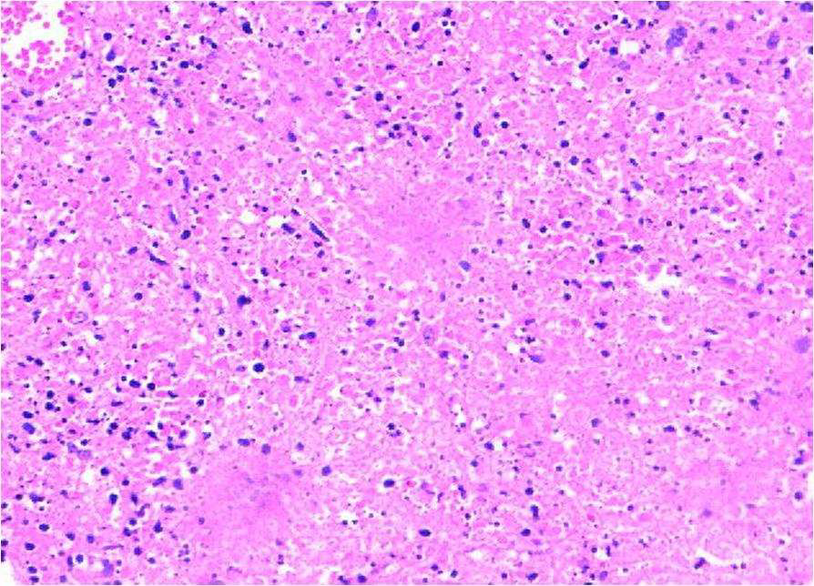
Figure 1: Lymph node biopsy section showing patchy areasof necrosis, proliferation of pale histiocytes, increase numberof apoptotic cells, cellular debris and nuclear dust(karyorrhexis) (H&E, x100)
Kikuchi-Fujimoto disease. Extensive paracorticalarea of coagulative necrosis (H&E, original magnification ×40).

CONCLUSION
Although the incidence of Kikuchi-Fujimoto disease is rare, this disorder must be considered among the differential diagnosis when a young patient presents with fever and cervical lymphadenopathy. Clinically Kikuchi’s disease may mimic lymphoma or systemic lupus erythematosus (SLE). Therefore a careful histopathological examination is necessary in arriving at the diagnosis. Early recognition of the disease is of crucial importance in minimizing potentially harmful and unnecessary evaluations and
treatments.

REFERENCES
- Dorfman RF. Histiocytic necrotizing lymphadenitis of Kikuchi and Fujimoto [editorial]. Arch Pathol Lab Med.
1987;111:1026-1029.
- Kuo T. Kikuchi's disease (histiocytic necrotizing lymphadenitis): a clinicopathologic study of 79 cases with an analysis of histologic subtypes, immunohistology and DNA ploidy. Am J Surg Pathol 1995;19:798–809.
- Sousa Ade A, Soares JM, de Sa Santos MH, Martins MP, Salles JM. Kikuchi-Fujimoto disease: three case reports. Sao Paulo Med J. 2010;128(4):232-235.
- Lin HC, Su CY, Huang CC, Hwang CF, Chien CY: Kikuchi's disease. A review and analysis of 61 cases. Otoralyngol Head Neck Surg 2003, 128:650-653
- Tsang WYW, Chan JKC, Ng CS: Kikuchi's lymphadenitis. A morphologic analysis of 75 cases with special reference to unusual features. Am J Surg Pathol 1994, 18:219-231.
- Bosch X, Guilabert A, Miquel R, Campo E: Enigmatic Kikuchi-Fujimoto disease: a comprehensive review. Am J Clin Pathol 2004, 122:141-152
- Louis N, Hanley M, Davidson NM. Kikuchi– Fujimoto disease: a report of two cases and an
overview. The Journal of Laryngology Otology 1994;108:1001-1004. doi:10.1017/ S0022215100128749
- Pileri AS, Pileri A, Yasukawa K, Kuo TS, Sullivan K: The Karma of Kiluchi's disease. Clin Immunol 2005, 114:27-29.
- Dorfman RF: Histiocytic necrotizing lymphadenitis of Kikuchi and Fujimoto. Arch Pathol Lab Med 1987, 111:1026-1029.

