
International Journal of Allied Medical Sciences and Clinical Research (IJAMSCR)

IJAMSCR |Volume 6 | Issue 3 | July - Sep - 2018
ISSN:2347-6567
www.ijamscr.com
Research article Medical research

Prevalence of kinesiophobia and its correlation with physiotherapy in post-operative total knee arthroplasty (TKA) patients - A cross sectional study

Pradnya Mahajan*¹, Jaywant Nagulkar ², Milind Kahile³, Shruti chavan⁴
¹MPTh, MVPS college of Physiotherapy, Nashik
²professor, Dr.Ulhas Patil College of Physiotherapy, Jalgaon
³Assistant Professor, Dr. Ulhas Patil College of Physiotherapy, Jalgaon
⁴BPTh, Dr.Ulhas Patil College of Physiotherapy, Jalgaon
*Corresponding Author: Pradnya Mahajan
Email id: ppradz1816@gmail.com

Abstract

Background
Kinesiophobia is a condition in which a patient has an excessive, irrational and debilitating fear of physical movement and activity resulting from a feeling of vulnerability to painful injury or re-injury. kinesiophobia had been widely assessed in various conditions including Parkinson’s disease, fibromyalgia, spinal stenosis and low back pain but its prevalence and influence on functional recovery after total knee arthroplasty remains unexplored.

Aim
To find out the prevalence of kinesiophobia and it’s correlation with physiotherapy in post-operative total knee arthroplasty (TKA) patients.

Methods
In this cross sectional study, 51 total knee arthoplasty patients were evaluated or assessed for kinesiophobia using Tampa scale of kinesiophobia. Also the patients were divided into 2 groups: Group A- total knee arthroplasty patients who received physiotherapy rehabilitation after total knee arthoplasty and group B- total knee arthroplasty patients who did not received physiotherapy rehabilitation after total knee arthroplasty. Both the groups were evaluated and compared for the presence of kinesiophobia.

Results
Z test for equality of two proportion was conducted (p< 0.05). Hence there is a significant difference between two ‘p’ values.

Conclusion
There was presence of kinesiophobia in total knee arhtroplasty patients .There was a significant difference in the level of kinesiophobia between post- operative total knee arthroplasty patients who received physiotherapy and those who did not.
Keywords: Kinesiophobia, Physiotherapy Rehabilitation, Total knee arthroplasty, Tampa scale.

Introduction
Pain related fear has been shown to be a very silent predictor of pain, disability and is even more predictive than biomedical status and pain intensity. It has been stated that pain-related fear is more disabling than pain itself. Pain related fear predicts future disability and health status in general population [1]. Kori et al. (1990) defined kinesiophobia as irrational, weakening and devastating fear of movement and activity stemming from the belief of fragility and susceptibility to injury [2].
If a human injures his leg, he may stop moving because he is too scared to move. This fear of movement is rooted in the belief that pain is harmful and threatening. This threat to basic livelihood promotes anxiety, pain and fear of movement. Once someone became paralyzed in fear, that person will avoid activities which affects the quality of life and functional deterioration. Patients with kinesiophobia believe that movement will cause re-injury and additional pain; therefore, kinesiophobia is a risk factor for persistent pain. In the long term kinesiophobia causes physical deconditioning, avoidance of physical activity, functional disability and symptoms of depression. Kori et al proposed a questionnaire aiming to diagnose kinesiophobia: The Tampa scale of kinesiophobia. The Tampa scale constitutes psychometric, clinically oriented, diagnostic, prognostic and monitoring tool [1].
Total knee arthroplasty is a surgical operation where the articular surface of a musculoskeletal joint is replaced in order to relieve pain and restore function to the joint after damage by arthritis or some other type of trauma. Degenerative osteoarthritis, rheumatoid arthritis, traumatic arthritis, tuberculosis arthritis, psoriatic arthritis, haemophillic arthritis and neuropathic arthropathy are among well known total knee arthroplasty indications.
Study carried out by Mari Lundberg et al. in Sweden reported that 54% of the patients with musculoskeletal pain present a high degree of kinesiophobia [3]. Since kinesiophobia is said to have a negative influence on the outcome of rehabilitation it would be of interest to investigate the occurrence in Indian population. kinesiophobia had been widely assessed in various conditions including Parkinson’s disease, fibromyalgia, spinal stenosis and low back pain but its prevalence and influence on functional recovery after total knee arthroplasty remains unexplored. Thus the present study aimed to know the prevalence of kinesiophobia and to compare level of kinesiophobia in patients who received physiotherapy rehabilitation and who did not after total knee arthroplasty.

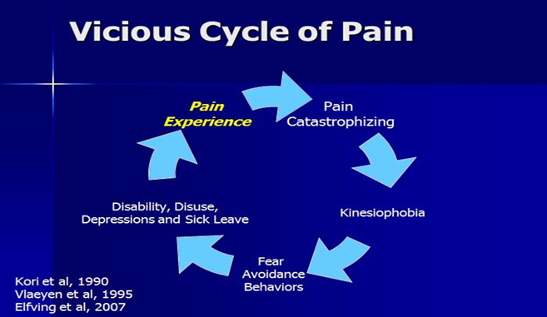

METHODOLOGY
Study design: Case Control Study
Study setting: Jalgaon
Duration of study- 1 year
Sample size: 51
Sampling technique: convenient sampling technique

Method of data collection
The study was performed at Jalgaon, Maharashtra, 51 patients were evaluated. Demographic data including gender, age, height, weight, body mass index, anthropometric data, history of surgical procedure, physiotherapy rehabilitation taken or not were recorded.
Kinesiophobia was evaluated using the Turkish version of the Tampa scale for kinesiophobia (TSK). This scale comprises 17 questions developed in order to measure fear of movement/ or re-injury. The scale includes injury/ re-injury and fear avoidance parameters. The scale uses 4 point scoring. A total score is calculated after inverting items 4, 8, 12 and 16. The individual obtains a total score ranging between 17 and 68. Higher score show a high kinesiophobia level. A cut off point of 37 was determined for the scale as ≥ 37 points indicate a high kinesiophobia level while <37 points indicate a low kinesiophobia level.
All data were computerized and analyzed by statistical packages for the social sciences (SPSS 11.0). Z test for equality of two proportion was conducted.

STATISTICAL ANALYSIS
Table no -1
Kinesiophobia | Freq | Percentage
Yes | 33 | 64
No | 18 | 36
Total | 51 | 100

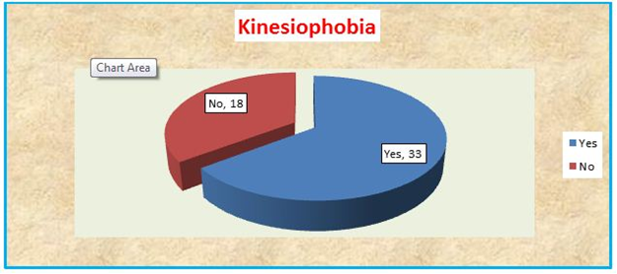
Figure 1.1- The pie diagram shows; out of total 51 patients 33(64%) patients had kinesiophobia and 18(36%) patients didn’t have kinesiophobia.

Table no -2
 |  | Kinesiophobia
 |  | yes | No | Total
Physiotherapy Rehabilitation | Physiotherapy rehabilitation received (Group A) | 15 | 18 | 33
Physiotherapy Rehabilitation | Physiotherapy rehabilitation not received (Group B) | 18 | 0 | 18

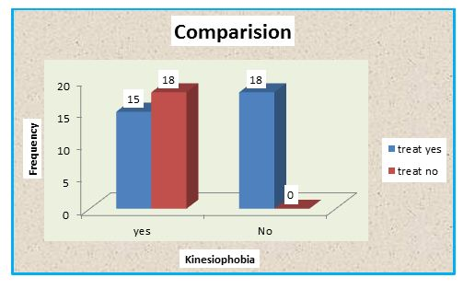

Figure 1.2 – The bar diagram illustrates, on y axis frequency of no of patients of kinesiophobia and on x axis level of kinesiophobia in patients who received physiotherapy rehabilitation or not. 33 patients taken physiotherapy rehabilitation out of that 15 had kinesiophobia and 18 didn’t have and 18 patients who didn’t take physiotherapy rehabilitation all 18 had kinesiophobia.

Proportion of kinesiophobia with treatment. | Proportion of kinesiophobia without treatment. | Z value | Z table | P value | significance
P1=15/33= 0.45 | P2= 18/18=1.00 | 6.29 | 1.96 | 0.000 | significant
* p< 0.05 significant association between the patients who received physiotherapy and who didn’t.

DISCUSSION
This study is the first to examine the level of kinesiophobia and its correlation with physiotherapy in total knee arthroplasty patients. Based on the results of our study out of total study population 64% of total knee arthroplasty patients had high level of kinesiophobia. The level of kinesiophobia is related with physiotherapy rehabilitation i. e out of51 patients 33 patients received physiotherapy rehabilitation among them 18 patient had no kinesiophobia and only 15 patients had low level kinesiophobia while those 18 patients who didn’t received physiotherapy rehabilitation all 18 had high level of kinesiophobia. This results signifies the importance of physiotherapy rehabilitation.
The patients who didn’t receive physiotherapy rehabilitation program had increase level of kinesiophobia than who received.
And the patients who received physiotherapy after TKR and having kinesiophobia because of following factors that comes out during study,
- Short duration rehabilitation program(<12 weeks)
- Lack of proper pre-op and post –op rehabilitation councelling.
- Trauma or fall history after or before surgical procedure because of poor cognitive and vestibular function.
The patients with kinesiophobia having quadriceps weakness, uneven distribution of weight, deformity, altered joint biomechanics, reduced range of motion, reduced joint strength which leads to worse functional performance and affects individual quality of life.
In the long term, kinesiophobia is reported to be associated with decreased physical fitness, avoidance of physical activity, functional disability, inability to fulfill social roles, and depression. Kinesiophobia is a factor influencing the outcome after TKA independently from other psychological and physical variables. This risk factor may affect TKA results, especially in women, and shows a further synergic interaction with depression in terms of lower surgical outcome. Increasing attention has been given to self-efficacy in explaining pain and pain disability. self- efficacy as the strongest predictor of pain disability, suggesting self-efficacy as a mediator between pain-related fear and avoidance behaviours in the fear avoidance model. However, the mediating effect was dependent on the level of self-efficacy, i.e., when selfefficacy was high, elevated pain-related fear did not lead to greater pain and disability.
Disabilities that are associated with kinesiophobia in post- operative total knee arthroplasty patients may be a combination of psychosocial factors and alterations in bodily functions. This complicates the ability of patients to control their pain. The Tampa scale for kinesiophobia has been used as a powerful selector of patients pain, psychosocial profiles. Our study aimed was to promote and maintain the highest degree of physical, mental, social wellbeing and improve quality of life in patients with kinesiophobia after TKR.
.

CONCLUSIONS
Kinesiophobia is a factor influencing the outcome after TKA independently from other psychological and physical variables. There was a significant difference in kinesiophobia between post-op TKA patients who received physiotherapy and those who did not. Kinesiophobia is a factor influencing the outcome after TKR .These findings are of clinical relevance because they show the impact kinesiophobia and suggest the adaptation co-interventions to overcome fear of physical activity and in the end improve patient recovery and final outcome after TKA.

REFERENCES
- Waddell G, Newton M, Henderson I, Somerville D, Main CJ. A Fear-Avoidance Beliefs Questionnaire (FABQ) and the role of fear avoidance beliefs in chronic low back pain and disability. Pain 52, 1993, 157/168.
- Kori S, Miller R, Todd D. Kinisiophobia: a new view of chronic pain behavior. Pain management 35, 1990, 43
- Duygu Kurtulus, Betul Sozeri et al. kinesiophobia after total knee arthoplasty.research and educational hospital, Istanbul; 13, 2017.
- G. Filardo, G. Merli, A. Roffi, T. Marcacci, F. Berti Ceroni, D. Raboni, B. Bortolotti, E. Kon, M. Marcacci. Kinesiophobia and depression affect total knee arthroplasty outcome in a multivariate analysis of psychological and physical factors on 200 patients; © 2016 Springer International Publishing; 10, 2016, 1007/s00167-016-4201-3
- Mari Lundberg, Maria Larsson, Helene O¨ stlund and Jorma Styf. kinesiophobia among patients with musculoskeletal pain in primary healthcare; J Rehabil Med 38, 2006, 37/43
- C. D. Gregg, G. McIntosh, H. Hall, H. Watson, D. Williams, and C.W. Hoffman, “The relationship between the tampa scale of kinesiophobia and low back pain rehabilitation outcomes, ”Spine Journal, 15(12), 2015, 2466–2471.
- M. Monticone, S. Ferrante, E. Ambrosini, B. Rocca, C. Secci, and C. Foti, “Development of the Tampa Scale of Kinesiophobia for Parkinson’s disease: confirmatory factor analysis, reliability,validity and sensitivity to change,” International Journal of Rehabilitation Research, 38(2), 2015, 113–120.
- Blozik E, Laptinskaya D, Herrmann-Lingen C, et al.: Depression and anxiety as major determinants of neck pain: a cross-sectional study in general practice. BMC Musculoskelet Disord, 10, 2009, 13.
- Crombez G, Vlaeyen JW, Heuts PH, Lysens R. Pain-related fear is more disabling than pain itself: evidence on the role of pain-related fear in chronic back pain disability. Pain 80, 1999, 329_/339.
- Vlaeyen JW, Kole-Snijders AM, Boeren RG, van Eek H. Fear of movement/(re)injury in chronic low back pain and its relation to behavioral performance. Pain 62, 1995, 363 /372
- Sullivan HJL, Bishop SR, Pivik J. The Pain Catastrophizing Scale: development and validation. Psychol Assess 7, 1995, 524–32
- Miller R, Kori S, Todd D. The Tampa Scale. Unpublished report. Tampa; 1991
- Lethem J, Slade PD, Troup JD, Bentley G. Outline of a Fear- Avoidance Model of exaggerated pain perception-I. BehavRes Ther 21, 1983, 401 _/408
- Nederhand MJ, Ijzerman MJ, Hermens HJ, Turk DC, Zilvold G, Swinkels-Meewisse IE, et al. Predictive value of fear avoidance in developing chronic neck pain disability: consequences for clinical decision making. Arch Phys Med Rehabil 85, 2004, 496 _501.
- Kuch K. Psychological factors and the development of chronic pain. Clin J Pain 17(l 4), 2001, S33 _/38.

How to cite this article: Pradnya Mahajan, Jaywant Nagulkar, Milind Kahile, Shruti Chavan. Prevalence of kinesiophobia and its correlation with physiotherapy in post-operative total knee arthroplasty (TKA) patients - A cross sectional study. Int J of Allied Med Sci and Clin Res 2018; 6(3): 602-607.
Source of Support: Nil. Conflict of Interest: None declared.

